## Changing the Distance on the Marker

* Select the Marker
* Double click on the distance number provided
* The writing cursor will appear and will allow you to enter your desired distance
* Click anywhere on your plan to finish
* 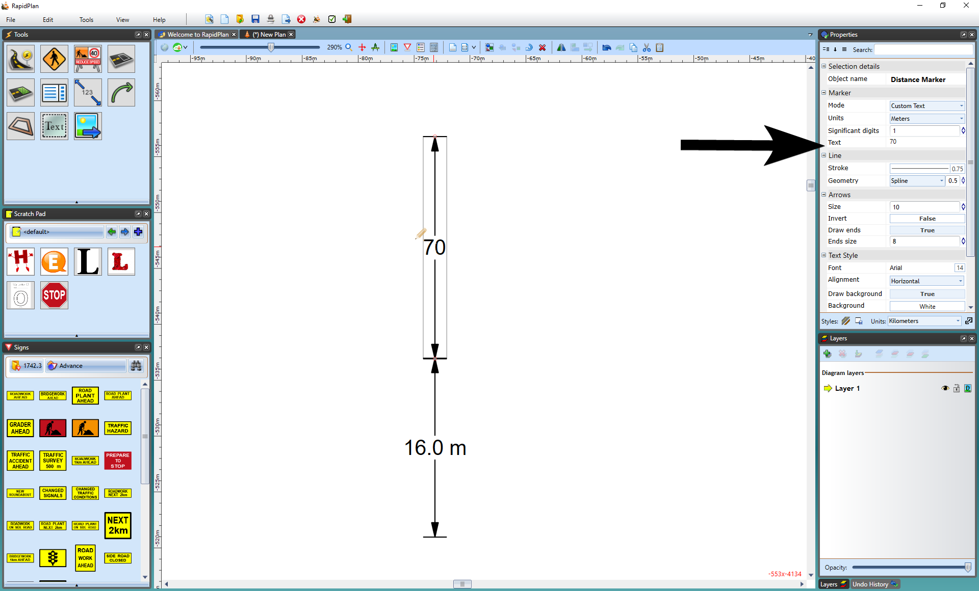
* Changing_the_Distance_on_a_Distance_Marker